**Experiment No. 4**

**Aim:** Setting up Linux proxy server.

1. **Update latest package list:**

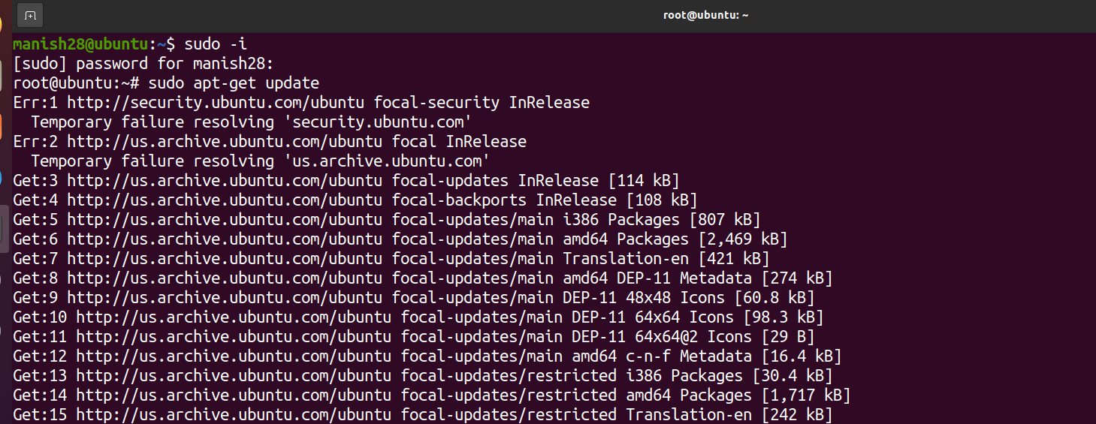

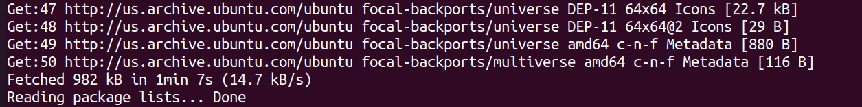

1. **Install Squid proxy server:**

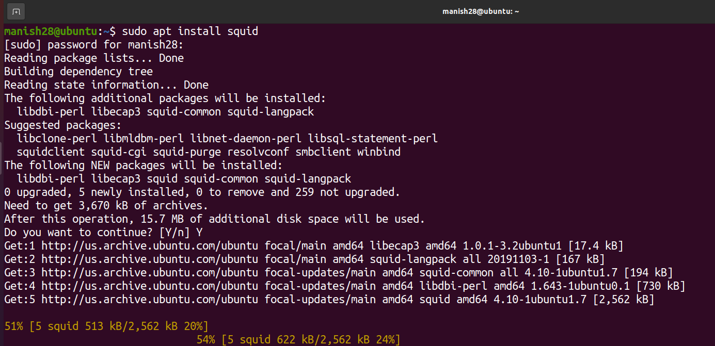

1. **Start and enable proxy server:**

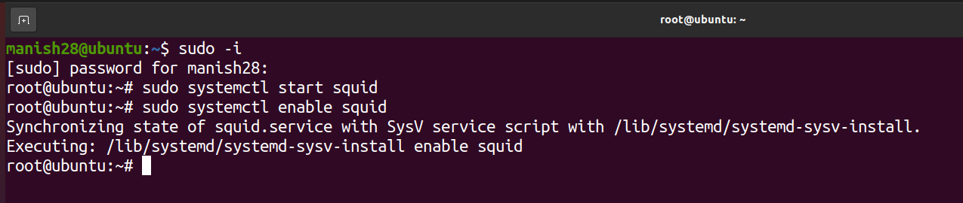

1. **To see the status:**

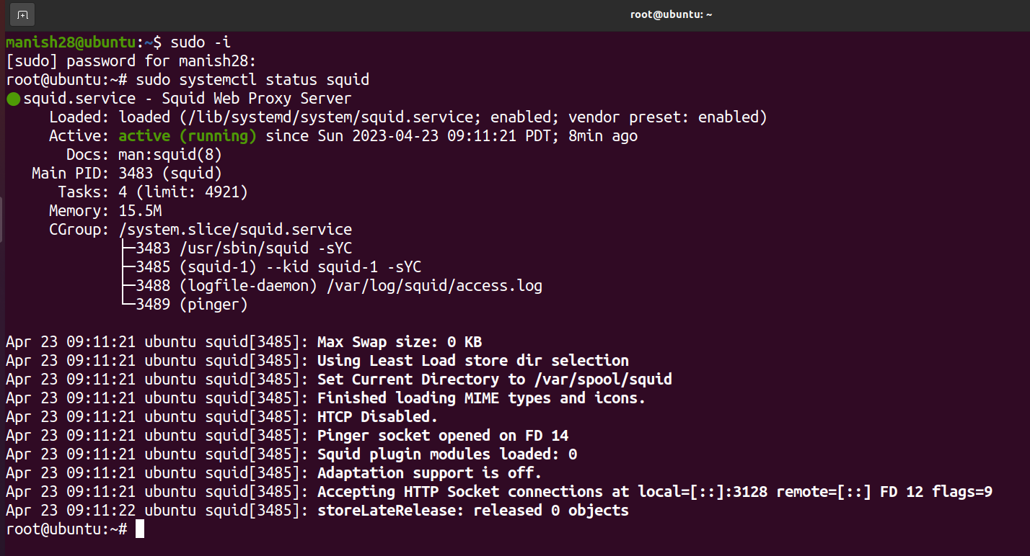

1. **To see which proxy port is running:**

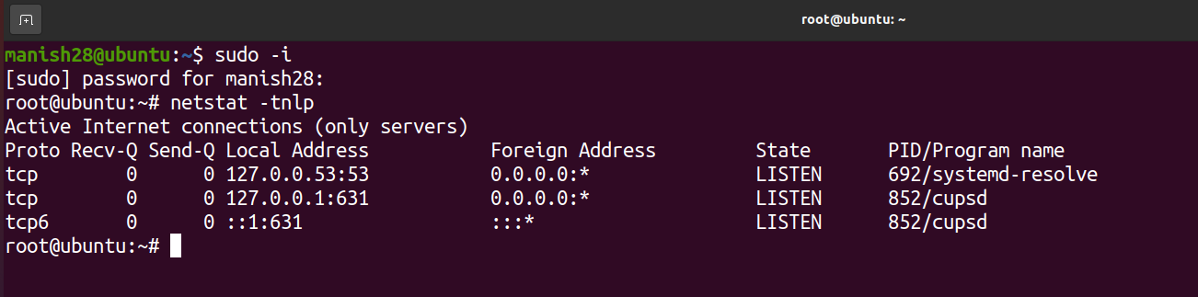

1. **To restart squid:**

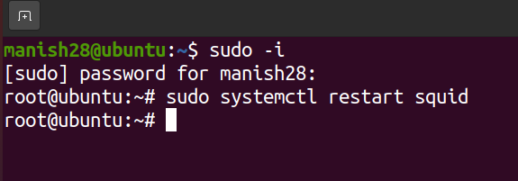

1. **Configure Proxy Sources to Access Internet:**

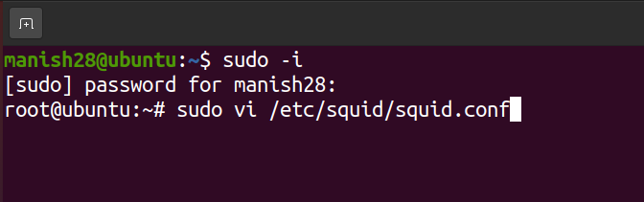

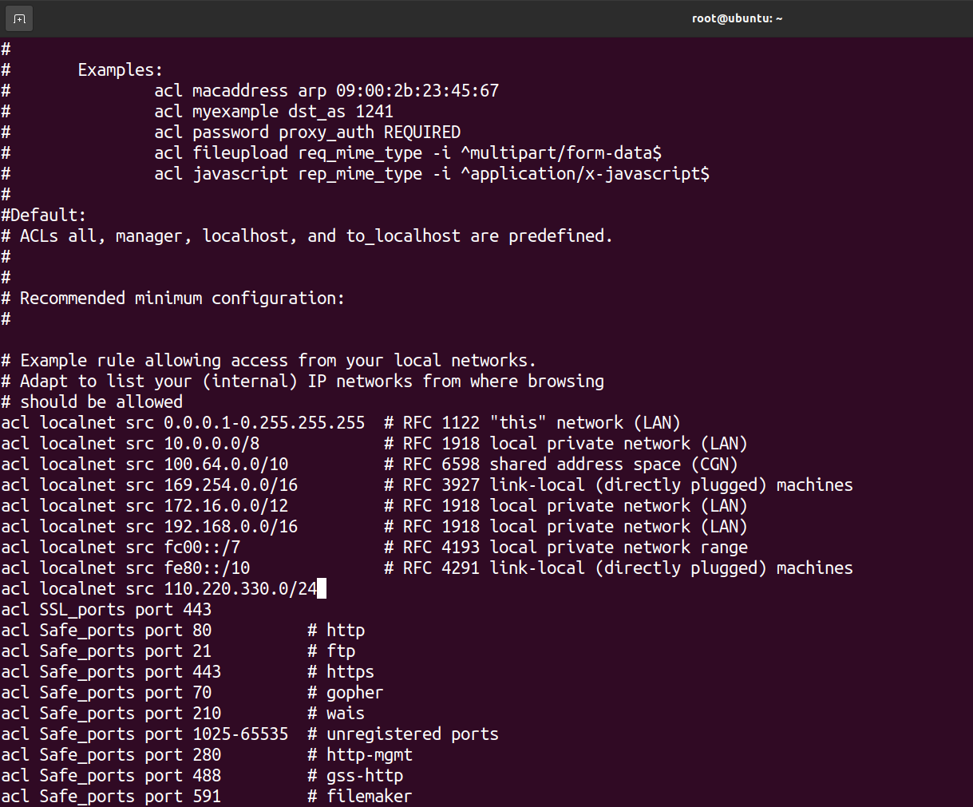

1. **To block websites:**

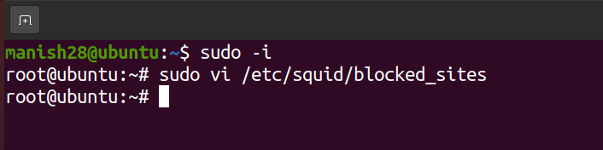

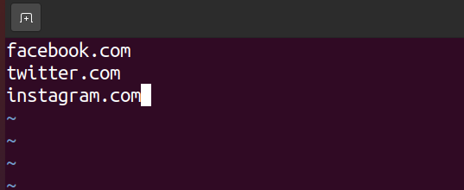



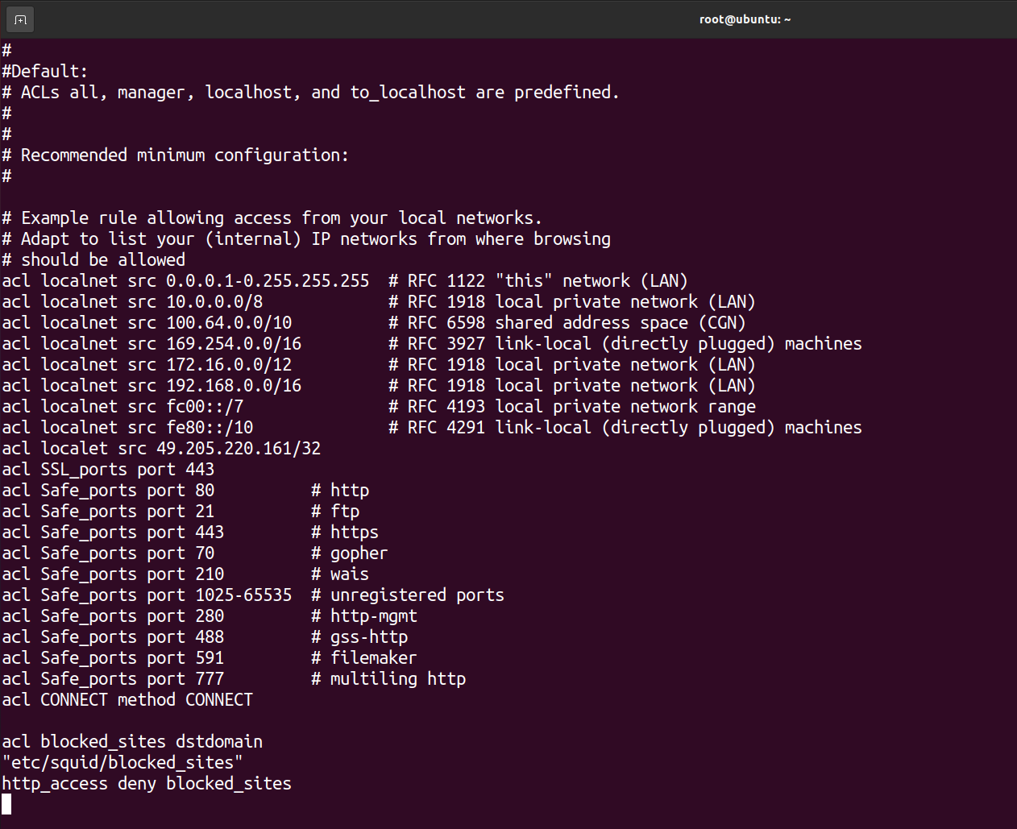

|  |  |  |  |
| --- | --- | --- | --- |
| **Practical Performance**  **(4)** | **Writeup & Oral**  **(4)** | **Attendance**  **(2)** | **Total**  **(10)** |
|  |  |  |  |